
LESSON NOTE | DETAILED EXPLANATORY NOTES
NEUROSCIENCE & AI
SENSE — THE EYE AND VISION
GRADE 12 - BIOLOGY
■ ■ ■

The Sense of Vision
Vision is the sense that lets us detect light and build a picture of the world. The organ of vision is the eye, which works like a living camera: it focuses light onto a light-sensitive layer, the retina, where photoreceptor cells convert the light into nerve impulses. These impulses travel along the optic nerve to the brain, which interprets them as the images we 'see'.
This lesson describes the structure of the eye, how light is focused onto the retina, how the rods and cones detect light and colour, and how the signal reaches the brain. It builds on the earlier lesson about sensory receptors, using the eye as a detailed example of a photoreceptor organ.
Why Vision Matters
- Vision is our main sense for navigating and understanding the world.
- It shows how a sense organ focuses and detects a stimulus (light).
- The retina is a clear example of transduction - light to nerve impulse.
- Understanding the eye helps explain eye disorders and their treatment.
The Eye and Vision
Key Learning Outcomes
By the end of this lesson, students should be able to:
- Label the main parts of the eye and state each function.
- Explain how light is focused by the cornea and lens onto the retina.
- Describe how the iris controls the amount of light entering the eye.
- Compare rods and cones and explain how they detect light and colour.
- Trace the visual pathway from light to the brain.
The Structure of the Eye
The eye is a fluid-filled ball with several specialised parts. The tough outer sclera (the white of the eye) protects it, while the transparent cornea at the front lets light in and begins to focus it. Behind the cornea, the coloured iris controls the size of the pupil - the hole that light passes through. The lens then fine-tunes the focus, projecting a sharp image onto the retina lining the back. The retina contains the photoreceptors; its most sensitive spot is the fovea. Signals leave the eye through the optic nerve.
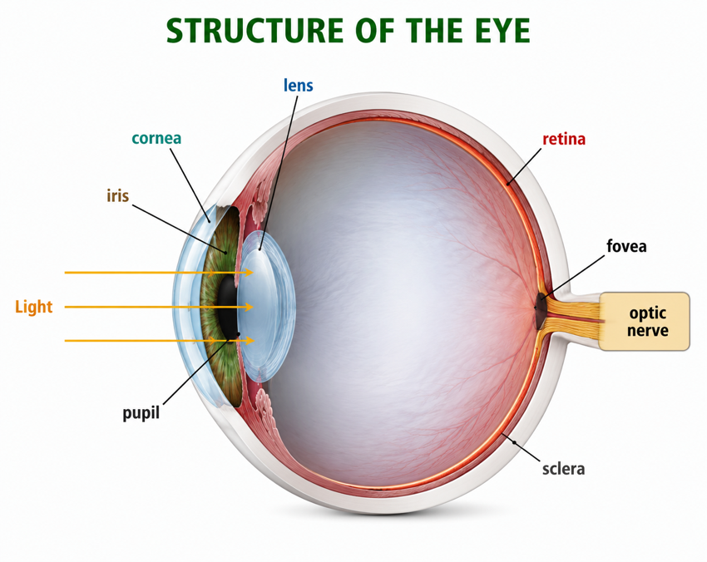
Figure 1: The structure of the eye - light passes through the cornea, pupil and lens to focus on the retina.
Terminologies and Concepts
Useful terms for this topic:
- Cornea: the clear front layer that lets in and begins to focus light.
- Iris: the coloured ring of muscle that controls pupil size.
- Pupil: the opening that lets light into the eye.
- Lens: focuses light sharply onto the retina (accommodation).
- Retina: the light-sensitive layer containing rods and cones.
- Fovea: the point of sharpest vision, packed with cones.
- Optic nerve: carries impulses from the retina to the brain.
Focusing Light - How the Eye Sees Clearly
For a sharp image, light rays must be bent (refracted) to meet exactly on the retina. Most of this bending is done by the cornea, and the lens makes fine adjustments. To focus on near objects the lens becomes fatter and rounder; for distant objects it becomes thinner and flatter - this adjustment is called accommodation. Meanwhile the iris controls how much light gets in: in bright light it makes the pupil small; in dim light it opens the pupil wide. Together, focusing and light control produce a clear, correctly exposed image.
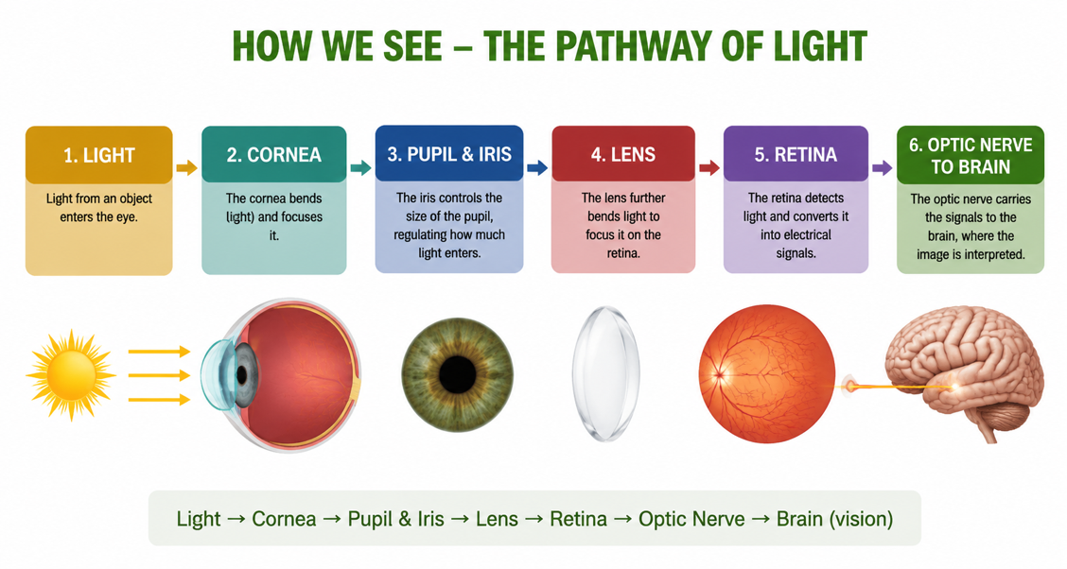
Figure 2: The visual pathway - light is focused on the retina, and the optic nerve carries the signal to the brain.
Rods and Cones - Detecting Light and Colour
The retina's photoreceptors come in two kinds. Rods are extremely light-sensitive and work in dim light, but they see only in black and white and give less detail; they are spread around the edges of the retina, giving night and peripheral vision. Cones need brighter light and detect colour and fine detail; they are concentrated at the fovea. There are three types of cone (roughly red, green and blue sensitive), and the brain combines their signals to produce full-colour vision. This is why colours fade and detail is lost in dim light - only the rods are working.
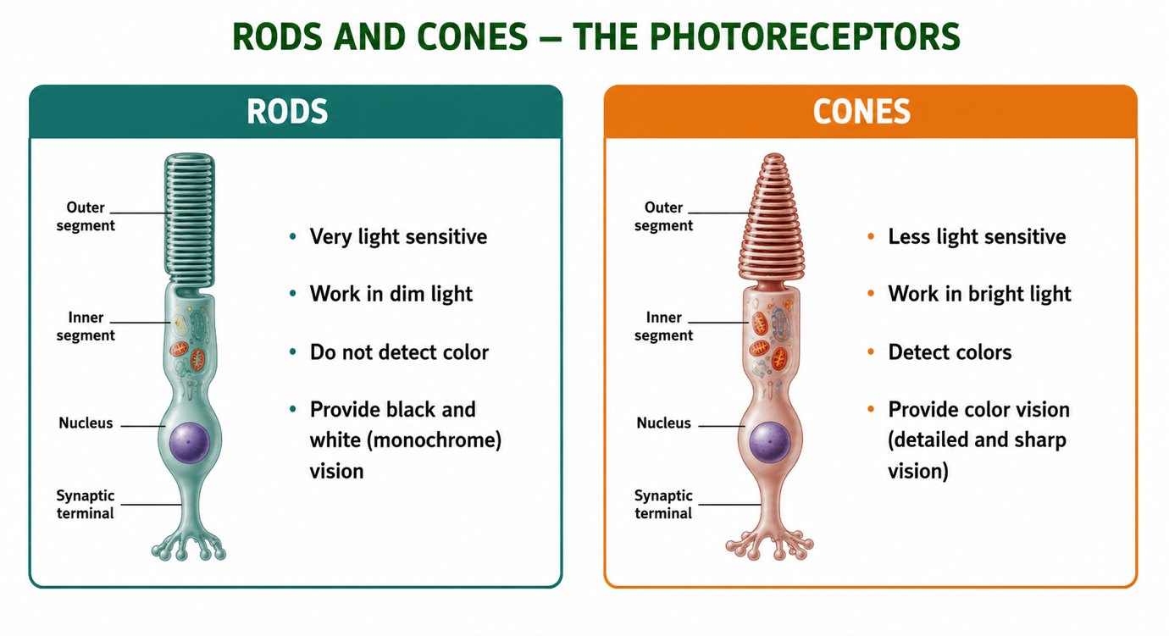
Figure 3: Rods work in dim light without colour; cones detect colour and detail in bright light.
From Eye to Brain - The Visual Pathway
When light strikes a rod or cone, it triggers transduction: the photoreceptor converts the light into a nerve impulse. These impulses pass through connecting neurons in the retina and leave the eye along the optic nerve. The signals travel to the visual cortex at the back of the brain, which interprets them - combining shape, colour, movement and depth into the single, meaningful image we experience as sight. Importantly, the image formed on the retina is upside down, and it is the brain that turns it the right way up.
Why This Matters
- Everyday life - vision guides almost everything we do.
- Health - understanding the eye explains problems like short/long sight and cataracts.
- Model sense organ - the eye clearly shows focusing, detection and transduction.
- Technology - cameras and robot 'vision' are modelled on the eye.
PNG Context Example
Eye health is a major issue in Papua New Guinea. Cataracts (clouding of the lens) are a leading cause of blindness, and can be treated by replacing the lens; trachoma and other infections can damage the eye; and vitamin A deficiency can harm the rods and cause night blindness, since rods need vitamin A to work. Uncorrected short and long sight also affect learning when children cannot see the board or read clearly. Understanding how the eye focuses light and how rods and cones work helps students appreciate the value of eye care, nutrition and glasses in their communities.
References & Related Documents
Source Documents
- STEM Biology Syllabus - Grade 12. Thema: Neurophysiology; Module: Sense - The Eye and Vision. Department of Education, PNG.
- Biology Standards-Based Syllabus, Grades 11 & 12 (PNG SBC 2020) - Strand 2: Life; investigate the structure and function of sense organs, using the eye as an example of light detection.
Further Reading & References
- OpenStax Biology - Vision; The Structure of the Eye; Rods and Cones. https://openstax.org/books/biology
- Khan Academy - Vision and the eye. https://www.khanacademy.org/science/biology/human-biology

